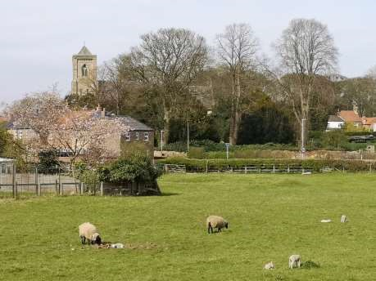

The Newsletter for Middleton on the Wolds

Issue No 15

May 2020

NEXT COPY DATE

14th May

Please send in your contributions to middletonflyer@yahoo.com. If I don’t acknowledge them please get in touch to make sure they have arrived.
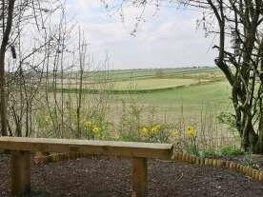
We are sorry that some villagers weren’t able to see the April edition of the Messenger which went out by email because of the current movement restrictions. This month we have had a limited number of copies printed which will be available in the Post Office. Please do not take one of these if you are able to read it online, but do take one for a neighbour without a computer.
If you are confined to your homes I hope you are managing to get some fresh air and exercise. Dave and I are taking a daily walk and finding many new paths around the village. We try to vary the route but often find ourselves on the old railway embankment.
Since Martha, Lola and Peyton cleared a viewpoint on the embankment for Lifestyle 2019 we have been intending to go and find it. Now we love to take a brief rest during our walk and sit on the bench looking over the fields and enjoying the birds who visit the feeders.
Although the streets and paths are very quiet we do come across people occasionally and have found that everyone is very courteous, keeping the required 2 metre social distance as we pass the time of day. We feel we are very lucky to live in Middleton on the Wolds.

Lyn

4 The Paddocks 219500

editorial
Well, we’re into the second period of lockdown and, apart from the few antisocial idiots who just can’t go on without seeing their mates or who simply must go to their holiday home in the country, it’s been refreshing to see how socially responsible most people, both nationally and locally, are being. Dog walkers are observing social distancing but seem to have realised
that you can still have a chat even if you are two metres apart (although if two of you stand on opposite sides of Warter Road how does someone walk between you safely?). It has also been uplifting to see the number of rainbows in windows and other little touches to brighten up the village, from the Easter goody bags on South Street to the Teddy bears’ picnic on Church Hill to the messages written on Warter Road.
And what about the Thursday night applause for key workers? I don’t know about other streets, but it’s been very well supported on Church Hill. I just hope that when life gets back to normal (whichever ‘normal’ that turns out to be!) we don’t forget that the same key workers will still be working hard doing their vital work and still often on low wages.
Which brings me to my next point. As a measure to combat the spread of virus the government is suggesting strict controls on travel from Coronavirus hotspots into the UK. But not, apparently, the two planeloads of lettuce pickers from Romania. It seems they are needed because not enough UK citizens are willing to do the work. Maybe it’s because of the low pay offered by the farmers. If it is then we, as consumers, have to share some of the blame. Farmers have to keep their costs down because the major supermarkets continually hammer them over prices. The rest of us look for the lowest prices we can but many of us don’t appreciate the consequences. Perhaps we should all think about paying a reasonable price rather than the lowest. It might mean consuming less but that would also mean throwing away less.
On a totally different subject May the 8th is the 75th anniversary of the end of World War Two in Europe. I know the events of the last few weeks have overtaken this but I have heard that some places around the country are celebrating by decorating their houses, towns and villages in red, white and blue. Wouldn’t it be great to see Middleton all dressed up?
By the time you read this we may be close to a relaxation of the lockdown rules. If there is change from May the 7th it might show that what we’ve gone through has actually worked. So, don’t go mad just because you can. The current rules aren’t there to stop us catching the virus, they’re there to slow down the rate at which we catch it so as not to overwhelm the health and emergency services. So, if you have to go out, fine; if you don’t have to, DON’T!
Cheers,
Mike
If you have any ideas, comments or complaints (especially complaints) you want to share then send an email to middletonflyer@yahoo.com.
Remember, we can’t respond unless we receive your message.
TO MAKE YOU SMILE
Just seen a news report about the stresses and strains of self isolation. It reported that people are going crazy from being in lockdown!
It was strange, because I had just been
talking about this with the microwave and toaster and all of us agreed that things are getting bad. I didn't mention anything to the washing machine as she always has to put a different spin on everything, and certainly not to the fridge as he is acting cold and distant. In the end the iron calmed me down. She said everything will be fine, which surprised me because she's usually the first one to apply unnecessary pressure and get steamed up over nothing!

PRODUCE SHOW 2020

Due to the COVID
-
19
situation we regret that the
show has been cancelled until next year

Sue Howden

Show Secretary

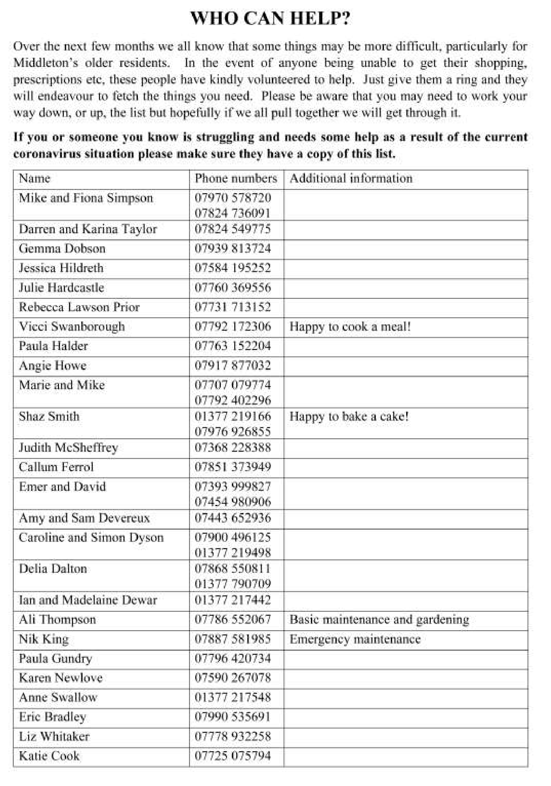

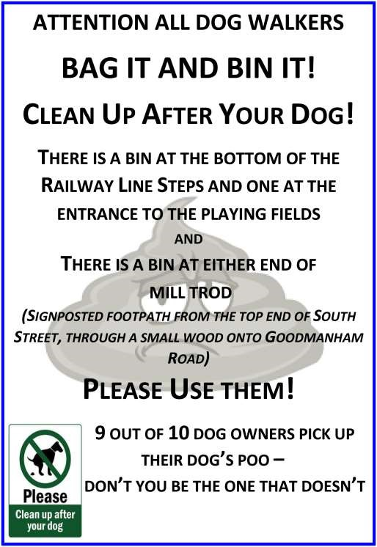

QUIZ PAGE
1 In total 623 people appear on what 11th century embroidery 2 What rebuilt London Church opened for services in 1697?
- Mars was the father of what mythological twins?
- What BBC legal drama is set in shoe lane chambers?
- Melon is an anagram of what other fruit?
- Literary character Ann Shirley lived on what farm?
- Grace Darlings father looked after what type of building?
- The Booth is the 11th fence on what famous racecourse?
- Neil Diamond starred in the remake of what Al Jolson film?
- What is the name of a male badger?
Quiz set by Rowland Wooldridge
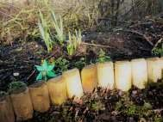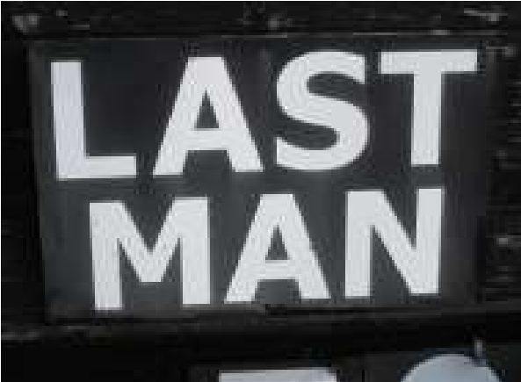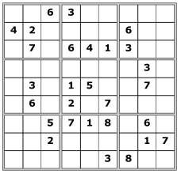

MOVIE DINGBATS

SUDOKU

WHERE IN MIDDLETON?

All answers on page 15

Photos by Ian Lavender

A note from your vicar
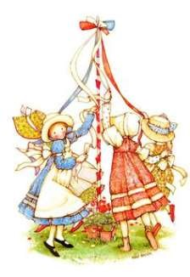
The Month of May
The month of May has been celebrated for centuries.
Celebrations often centred around a female figure. In ancient Rome the goddess Flora was the goddess of Spring: ceremonies in her honour marked the return of vegetation to the earth after the long, harsh, barren months of winter. Flora is most probably the inspiration for the May
Queen which many of you may remember – in my first parish in Timperley (where the famous rhubarb comes from) we still had a May celebration – on the Saturday we had a Spring Fair (with May pole dancing) at which a young girl was crowned ‘May Queen’ and on the Sunday she and her retinue all sat in the sanctuary in church for the service. As is often the case in the church, pre-Christian customs are often ‘adopted and adapted’. So, May became Mary’s Month and statues of Mary the Mother of Jesus would (and indeed still are) be crowned with a chaplet (garland) of roses.

The chaplet was a well known love token in the Middle Ages. This is where we also have the name rosary beads, as they were originally carved in the shape of little roses.

Laying flowers before Mary’s statue was once very popular and often brides would lay their wedding bouquets before a shrine of Mary after the wedding ceremony and pray there for a blessing on their marriage.

May is the month of Mary,
Bright is the sun above Bluebells all nod in chorus Joining our song of love.

Many places in Britain have May ceremonies – on of the most famous is the singing of a Latin carol from the top of Magdalen Tower in Oxford very early on the 1st May.

Dancing around a Maypole is most definitely a pagan custom. It symbolises an ancient fertility rite. The Puritans disliked it and it was banned in Cromwell’s day. However, it was restored joyfully with the return of the king. Many schools still do it today and there is a real art to teaching the children the right steps so that the colourful ribbons are woven beautifully around the pole and then the dance is reversed so the ribbons are unwound again. A giant May pole was once erected each year in London: the name of the Anglican Church of St Andrew Undershaft commemorates it: it was under the shadow of the huge pole.

As May is a month of flowers, we could perhaps take a little time to find out more about our garden or hedgerow flowers – there are many beautiful legends associated with them. You could also try pressing flowers from your garden to use to make cards for family and friends. Buttercups and daisies make lovely pressed flowers – place between two sheets of blotting paper, card would be an ok substitute, and sandwich between heavy books for about a week until they have dried out then you can use them to make cards, bookmarks, keyrings whatever takes your fancy. Happy crafting!

Jane 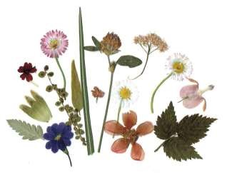

St Andrew’S church &
The wolds METHODIST CHURCH bainton
These churches are closed until further notice.

Parish council
As a result of the Coronavirus outbreak we have also been advised that all future Parish Council Meetings should be cancelled until further notice.
The Parish Council is still functioning through the clerk, in consultation with the chair. The Clerks contact details are: 01262 470496, or by e-mail pc@middletononthewolds.co.uk

obituary

Mr Gerald P. Gray (Gerry)
A very restricted Service took place at the York Crematorium on 26th March celebrating the life of Gerry who died on 7th March following many years of debilitating pain which he fought with his indomitable spirit. Sadly in his latter years he developed Parkinsons and Vascular Dementia which also took their toll. Gerry was a Financial Consultant in York when he and his beloved wife Mary moved to Middleton in 1984.
Before retirement he had been a Magistrate and member of the Citizens Advice Bureau and had also been an active member of the Lions Club in his younger life. Gerry was a very keen gardener and spent many happy hours transforming his large garden, he was a keen Pilates member and formed a thriving Gardening Club in the village. When in his seventies he became probably the oldest First Responder ever recruited!
Gerry had a good legal brain and was always ready to give a helping hand or give advice if required. He will be very sadly missed by those who knew

LOCAL HISTORY
END OF HOSTILITIES
“VE DAY. Fetched beer from Hull, was drunk.” Once again Tom’s diary captures the mood. After some indecision Churchill declared Tuesday the 8th of May 1945 as Victory in Europe Day and allowed a brief period of rejoicing before the massive task of national reconstruction started - and
the people did just that. The Germans had fought stubbornly to the end despite their cities being pounded day and night from the air and the allied armies converging on the fatherland from the east and the west. With the death of Hitler the war finally ended not with an armistice but with conquest and unconditional surrender so avoiding the possibility of a “stab in the back” myth arising as it did after the first war.

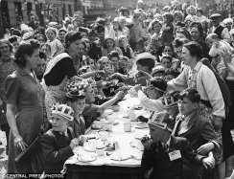
The scenes of rejoicing in London, with unrestrained antics and dancing in the streets, are well known and there were street parties throughout the land, bonfires lit, effigies burnt, songs sung with a mixture of laughter and tears but the future remained uncertain. Whatever optimism existed was summed up in the Vera Lynn song “We’ll meet again.”

We do not have details of any festive celebrations in Middleton and any information would be gratefully received. The present writer and his future wife remember street parties in North Hull and crowds on Queen’s Gardens and there is an official sound film available on line entitled “Hull Victory Celebrations” which is well worth watching.
On a more serious note the Driffield Times reported:

“On VE Day there was a United Thanksgiving service held in St. Andrew’s Church conducted by the Rector. On Sunday evening the church was crowded, all the various organisations in the village being represented. The service was conducted by the Rector and Mr W Eastwood was at the organ. Before the service a parade was held, the following attending: Home Guard, Civil Defence personnel, NFS, Royal Observer Corps, WVS, Women’ Section of the British Legion, Guides and Brownies, Boy Scouts and Cubs, Middleton Girls’Club. The collection was for the restoration of bombed churches in Europe.”

Following the explosion of atom bombs on two Japanese cities the war in the east officially ended on the 15th August 1945 and it was time for a new world order to emerge, potentially no safer than in 1918 especially with the introduction of nuclear weaponry, “the bomb” which would continue to haunt mankind.

For those who had gone off to war, whether their experiences were tolerable or deeply unpleasant, the return to civilian life could be more difficult than they had imagined. The comradeship built up serving in the forces together with shared ordeals in unfamiliar locations often meant that their homecoming could seem a little flat. Their return was not helped by the increasing austerity of postwar Britain, although in the village the rigours of food rationing could be alleviated by local connections-but no bananas of course. However the postwar Government, no doubt mindful of potential future threats to food supply, was to take agriculture more seriously than after the first war. The people on the Home Front often had parallel experiences of dislocation and bereavement so its true to say that the war changed most people in some way but the sheer awfulness of the Nazi and Japanese regimes and their global ambitions meant that conflict at some stage would have been inevitable so it is fitting to commemorate the 75th anniversary of VE DAY.

POSTSCRIPT

On a Saturday in early June 1972 the Hull Daily Mail carried its headline for the first time in French and a fleet of buses stood in a roped off part of King Edward street to take a party of French war veterans to different locations in East Yorkshire. Later the Driffield Times reported on the story:-

“The Rector of Middleton-on-the Wolds with Dalton the Rev. Cecil Hume welcomed over 60 French guests in the Village Hall. Most of the men had been billeted in the village and old friendships were renewed. Several of them immediately recognised Mrs Annie Hotham who was licensee of the Robin Hood public house for 26 years covering the war. After the official welcome many of the visitors called at the Robin Hood and sampled our English beer.”

Reference was also made to the fact that during the war several officers used to visit Mr and Mrs J W Noble at their home in Middleton.

(The quotations from Tom Soanes’ diaries are reproduced by kind permission of Mr and Mrs R Soanes.)

Geoff Wisher
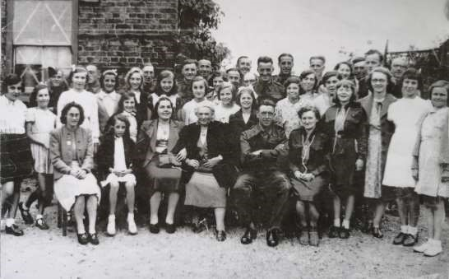
This picture was taken around the time of the second world war. Do you recognise anyone? Please let Geoff Wisher know by sending an email to middletonflyer@yahoo.com or ring Lyn on 219500.

Local Birds & wildlife

Well, things are still quite weird at the moment, but at least (as a few media people have already commentated) it is so quiet that we are more aware of the natural sounds around us; birdsong being the most obvious. This is absolutely the best time to listen to birdsong; if you are awake at dawn then all the birds are trying to outdo each other in order to attract partners and warn off rivals and it is amazing how many birds are around. Don’t despair if you are not around that early though, they do carry on through the day with gaps for feeding and, well, having a bit of a rest after all that shouting early on!
Just after the deadline for the last Messenger the first butterflies started to turn up, firstly for me a peacock, then a very small tortoiseshell then a brimstone. We have always been unable to get a good photo of a brimstone, they tend to fly over our garden and disappear to one side or the other, but in fact it turns out that if they stop to feed they close their wings over their backs, so we are probably not missing out there!

Our first report of a swallow in the village was on 10th April from Pat, but presumably it was passing through as I haven’t heard of any more (and the Yorkshire Post and the RSPB are still only reporting individuals). Pat’s report on 11th April was full of spring promise though “Young hedgehog visiting eating cat food. Thrush getting nesting material. Bluetits and sparrows nesting round the bungalow and a very busy wren. Also seeing red kites and buzzards.”

We are still getting used to the more open aspect at the end of our garden following the felling of a lot of the tall ash trees on the embankment. The plants in our garden are pathetically grateful for the extra light, and a bonus for us has been that the grey squirrels who used to gayly swoop down from the overhanging branches into the garden and attack the bird feeders found themselves exiled with a sudden area of chopped up undergrowth and brash to somehow find a way over.

We’ve been enjoying being out in the garden in the lovely weather and were surprised on 12th April by the raucous cries of seagulls* in the distance. They got nearer and nearer, then spent quite a while circling over the school, still calling all the while. I can only think that they had been asked by the RSPB to give people the illusion that they had been able to go to the seaside – we could all close our eyes, bask in the sun and imagine ourselves on a sandy beach!
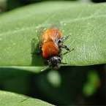
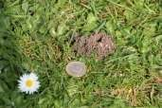
Last May I wrote about what I then thought were solitary bees, or possibly bee flies. This highlights the perils of leaving it until the deadline day to write this as I rushed through bee ID sites on the internet and failed to realise that they are actually tawny mining bees (I should have had a closer look to spot their little Davey Lamps and pickaxes). They fly just above the grass on the lawn in just one area, flying round in figure-of-eights until disappearing discreetly under a daisy leaf (they are only small) to begin digging. The tunnel they make can go more than half a metre deep, so if we get many more of them we may find ourselves suddenly knee-deep in the lawn.

It looks as though a lot of our wildlife-watching is going to be centred around our gardens for some time to come, so please keep an eye out for interesting “mini-beasts”, as well as birds and any passing mammals and let me know what you see – also send in any photos you can take of them.

Keep safe,
Barbara
Email me at lavenderbarbara97@gmail.com or phone/text 0777 192 7868

*Every wildlife programme and book point out that there are no such things as ‘seagulls’ but that there are many different types of gull. However, when they are flying quite high above you, and are just black shapes against the sky, I think we can be forgiven for generalising!

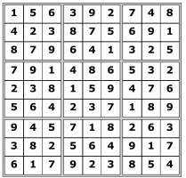
Quiz answers

Where in Middleton:

Cricket Ground

Rest Area on the Old
Railway Line

Dingbats:

From Here to Eternity

Doctor Dolittle

Carry on Doctor

Broke Back Mountain

The Turn of the Screw

1

Bayeux Tapestry

2

St Paul's Cathedral

3

Romulus and Remus

4

Silk

5

Lemon

6

Green Gables

7

Lighthouse

8

Aintree

9

The Jazz Singer

10

Boar

Middleton book group
April’s Virtual Meeting

As we are all isolated in our own homes we decided to try to get together via Zoom. It was rather experimental as I had only been on it a couple of times and had never hosted a meeting. However, after a few teething problems we managed to get 5 of us together on screen to discuss the books and, of course, the current situation in general. We hope to increase the number for the May meeting. The downside of course is there was no lovely cake and we had to provide our own cup of tea!

“The Man Who Didn’t Call” by Rosie Walsh

After Sarah met Eddie and they spent a wonderful week together he goes away for a holiday but doesn’t get in touch again. She is devastated and tries to find out if he is ok and why she has been dropped without a word. Reference is made to a tragedy when she was a teenager and the death of her younger sister’s best friend. Is this the link? There are many twists and turns, most of which I didn’t see coming. Those who had read the book enjoyed it.

“A Noise Downstairs” by Linwood Barclay

Paul witnesses a colleague about to dispose of 2 dead bodies before he is hit over the head himself. He recovers physically and visits to a therapist help him, but he starts to hear disturbing noises during the night. It is difficult to explain more without giving away some of the twists and turns (yes, again). More of a thriller, it was enjoyed by those who read it although it was slightly more predictable than “The Man Who Didn’t Call”.

Lyn

Next books for discussion:
May “The Lost Flowers of Alice” by Holly Ringland
“Nine Perfect Strangers” by Liane Moriaty

If anyone has any comment on any of the books that we mention we would be pleased to hear from you at the email below.

You can contact me to find out more about the Book Group on
219500 or lyndennis456@gmail.com

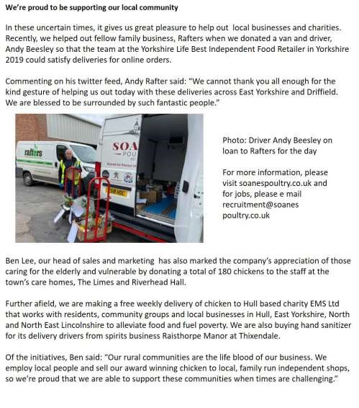
Advertising Feature

Advertisement
Advertisement

 | LOCAL CONTACTS Bell Ringing Chris Atkin |  | 217285
 | Book Group/Middleton Movers | Lyn Dennis | 219500
 | Bowls Club | Rob Bradley | 217435
 | Country Women’s Association | Christine Johnson | 217374
 | First Responders | Chris Brent | 219469
 | Line Dancing | Pat Pottage | 217516
 | Methodist Chapel | Miss P Hodgson | 217426
 | Middleton Messenger | Mike Kelly | 07713 620912
 |  | Lyn Dennis | 219500
 |  | Tina Walker | 217242
 | Middleton Womblers | Andrew Naylor | 219072
 | Parish Clerk | Sandra Morrison | 01262 470496
 | Reading Rooms | Kath Bentley | 217456
 | Recreation Club | Dave Newlove | 07901 833784
 | St Andrew’s Church | Rev Jane Anderson | 219471
 | St Andrew’s Church Warden | Roger Lowe | 217656
 | Table Tennis | Louise Newlove | 217801
 | Village Hall Lyn Dennis |  | 219500
ADVERTISING COSTS for the Messenger

Rates Month Year

Whole Page £25 £150

1/2 Page £15 £100
1/3 Page £10 £60

Full colour - Print run 500 copies

Contact: Tina 01377 217242, middletonflyer@yahoo.com

